CSE 220 Data Structures - Quiz 02
A
Date: 15 March 2025
Time: 25 minutes

Name: ID:

- Given a 13x15 matrix: [5 Marks]
  - Determine the corresponding row and column indices for the linear index 67.
  - Determine the linear index corresponding to row 8 and column 12.

a ⇒ row = 67 / 15 = 4
col = 67 % 4 = 7

b ⇒ 8*15 + 12 = 132

[Think what you would have to do in case of a 3D array. The process is very similar]

- Evaluate the postfix expression: 1 2 3 4 5 6 * + + + + 10 - [5 Marks]
Spaces separate numbers and operators. Show your solution step by step. At each step, draw your stack like [x y … z], where z is the top of the stack. The top of the stack should always be on the rightmost side. Just drawing the stack is enough, no need to explain anything.

[1] → push 1
[1 2] → push 2
[1 2 3] → push 3
[1 2 3 4] → push 4
[1 2 3 4 5] → push 5
[1 2 3 4 5 6] → push 6
[1 2 3 4 30] → pop 5,6, push 30
[1 2 3 34] → pop 4,30, push 34
[1 2 37] → pop 34, 3, push 39
[1 39] → pop 37, 2, push 39
[40] → pop 39, 1, push 40
[40 10] → push 10
[30] → pop 10, 40, push 30

answer : 30

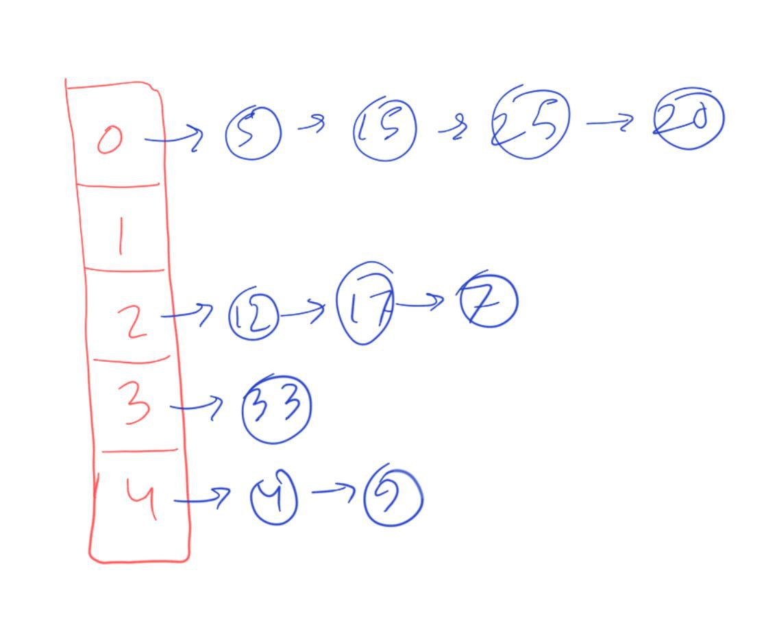
- You have a hash table of size 5, with the hash function key % 5. Insert the elements 12, 5, 17, 15, 25, 20, 33, 4, 7, 9 into the table. Use separate chaining to handle collisions. Draw the final hash table. [5 Marks]
k | h(k) = k % 5
12 | 2
5 | 0
17 | 2
15 | 0
25 | 0
20 | 0
33 | 3
4 | 4
7 | 2
9 | 4

